Basics of Cisco Packet Tracer Switches –

Switch –

A switch is a networking hardware which is used to connect multiple end devices to form a Local Area Network (LAN). The switch comes at the Second layer of the Networking model. It has a storage for memory. It stores the Senders and receivers MAC Address. Switch is Unidirectional, multidirectional, and Broadcasting device.

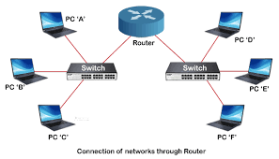

Working of a Switch –

When an end device connects to other devices for transfer of the data, it gets connected via LAN. Here each port of switch stores the MAC of the respective end devices it is connected to. The data packet is carried from the source, holding the MAC address, to the router and reaches the destination. The main advantage of switch is that it does not broadcast each data that is send through it by default.

Difference between Hub and Switch

HUB SWITCH

1. Layer 1 device 1. Layer 2 device.
2. Works at Physical layer 2. Works at Data Link Layer.
3. Has No memory 3. Can store MAC Addresses.
4. Not an intelligent device 4. Intelligent device.
5. Floods the networking due to broadcasting 5 . Can do unicasting, multicasting, broadcasting.
6. Security risks are high 6. Security risks are low.
7. Half Duplex 7. Full Duplex.